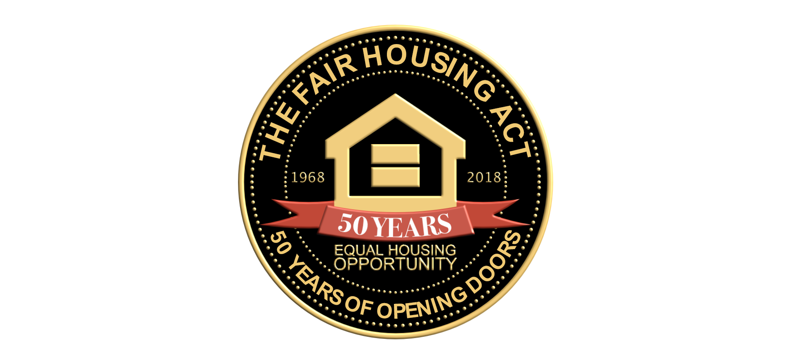

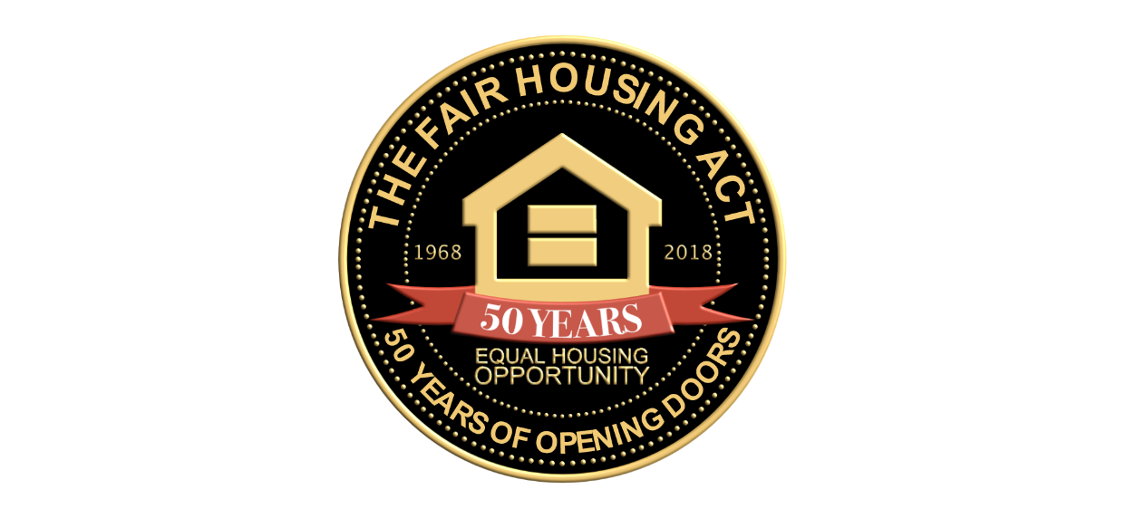

**FAIR HOUSING MEANS…..**

**Equal Housing Opportunities For All!**

**#FairHousingIs50**



**FAIR HOUSING MEANS…..**

**Fair Housing Opportunities For All!**

**#FairHousingIs50**



**FAIR HOUSING MEANS…..**

**Fair Housing Is Not An Option**

**It Is The Law**

**#FairHousingIs50**



**FAIR HOUSING MEANS…..**

**Equal Housing Options and Treatment “For All”**

**#FairHousingIs50**



**FAIR HOUSING MEANS…..**

**Non Discriminatory Treatment**

**#FairHousingIs50**



**FAIR HOUSING MEANS…..**

**Safer Neighborhoods!**

**#FairHousingIs50**



**FAIR HOUSING MEANS…..**

**#FairHousingIs50**



**FAIR HOUSING MEANS…..**

**Access**

**#FairHousingIs50**



**FAIR HOUSING MEANS…..**

**Greater Housing Opportunities**

**#FairHousingIs50**



**FAIR HOUSING MEANS…..**

**I Control My Housing Options**

**#FairHousingIs50**



**FAIR HOUSING MEANS…..**

**No Unfair Denial**

**#FairHousingIs50**



**FAIR HOUSING MEANS…..**

**Equality**

**#FairHousingIs50**